Tạo văn bản dự thảo

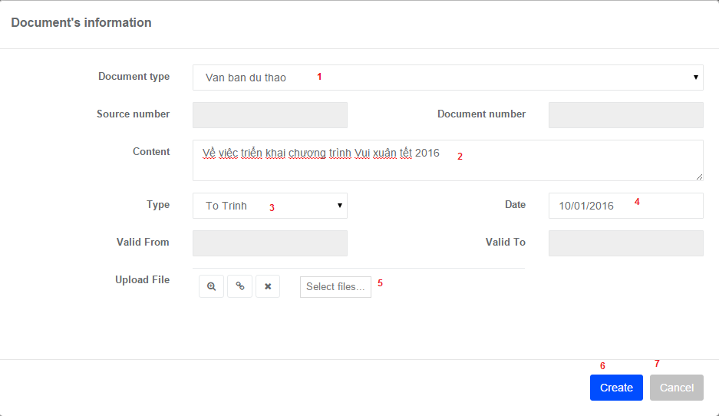

|  |  |  |  |  |  |  |
| --- | --- | --- | --- | --- | --- | --- |
| **No.** | **Name** | **Type** | **Validation** | **Event** | **Description** | **Status** |
| 1 | Document type | Combo box | Empty, character |  | Input document type |  |
| 2 | Content | Textbox |  |  | Input document subject |  |
| 3 | Type | Combo box | Empty, character |  | Input type |  |
| 4 | Date | Date picker | Character |  | Input document date |  |
| 5 | Select files | File chooser |  |  | Input attached file |  |
| 6 | Create | Button |  | Click | Submit creating new draft document |  |
| 7 | Cancel | Button |  | Click | Cancel creating |  |

Tạo văn bản ban hành

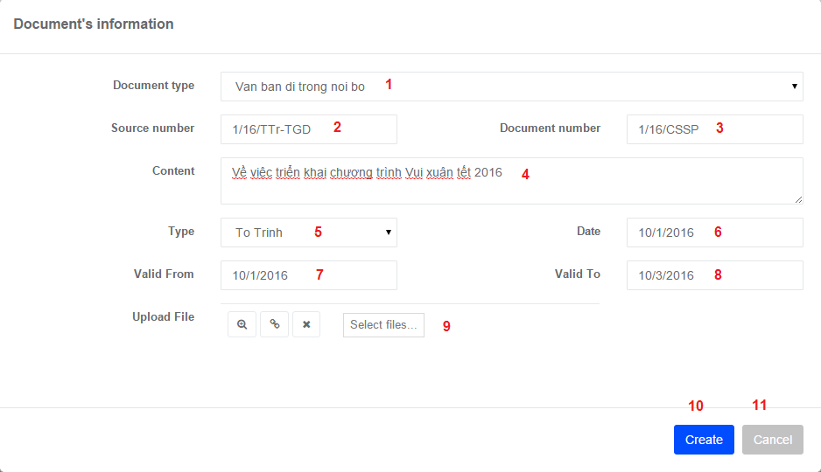

|  |  |  |  |  |  |  |
| --- | --- | --- | --- | --- | --- | --- |
| **No.** | **Name** | **Type** | **Validation** | **Event** | **Description** | **Status** |
| 1 | Document type | Combo box | Empty, character |  | Input document type |  |
| 2 | Source number | Textbox | Character |  | Input document source number |  |
| 3 | Document number | Textbox | Character |  | Input document number |  |
| 4 | Content | Textbox | Character |  | Input document subject |  |
| 5 | Type | Combo box | Empty, character |  | Input type |  |
| 6 | Date | Date picker | Character |  | Input document date |  |
| 7 | Valid From | Date picker | Character |  | Input document begin valid date |  |
| 8 | Valid To | Date picker | Character |  | Input document end valid date |  |
| 9 | Select files | File chooser |  |  | Input attached file |  |
| 10 | Create | Button |  | Click | Submit creating new published document |  |
| 11 | Cancel | Button |  | Click | Cancel creating |  |

Danh sách processing

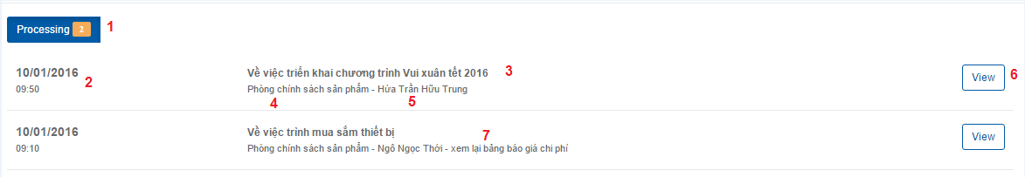

|  |  |  |  |  |  |  |
| --- | --- | --- | --- | --- | --- | --- |
| **No.** | **Name** | **Type** | **Validation** | **Event** | **Description** | **Status** |
| 1 | lblNoCount | label |  |  | Number of document or draft processing |  |
| 2 | lblCreateDate | label |  |  | Date when document was created |  |
| 3 | lblContent | label |  |  | Document Content |  |
| 4 | lblDepartmentName | label |  |  | Department Name |  |
| 5 | lblUserName | label |  |  | User Name |  |
| 6 | btnView | button |  | Click | Load document detail |  |
| 7 | lblDescription | label |  |  | Comments on document |  |